

Hash Your First Block – Blockchain Basics and Setup.



**Objective/Aim:**  
  
 To understand the basics of blockchain technology, set up the Egeth environment, and perform a demonstration of hashing and mining a block.

**Apparatus/Software Used:**

* Laptop
* Egeth (Ethereum client)
* Internet (for research and online blockchain demo tool)

**Theory/Concept:**

**What is blockchain?**

Blockchain is a shared, immutable digital ledger used to record transactions and track assets in a business or public network, ensuring a single source of truth.

* Data in a blockchain is stored across multiple nodes (computers) in the network.
* Once data is recorded, it cannot be altered or erased without consensus.

**The evolution of blockchain:**

* Introduced in 2008 with the launch of Bitcoin by Satoshi Nakamoto.
* Evolved to support smart contracts, tokenization, and decentralized applications beyond cryptocurrencies.

**Key features of blockchain technology**

* Distributed Ledger Technology (DLT) – All participants share and synchronize records.
* Immutable Records – Data, once written, cannot be modified.
* Smart Contracts – Self-executing code that runs on the blockchain.
* Public Key Cryptography – Ensures secure ownership and transaction signing.



**Procedure:**

|  |  |  |  |
| --- | --- | --- | --- |
|  |  |  |  |
|  |  |  |  |
|  |  |  |  |
|  |  |  |  |
|  |  |  |  |
|  |  |  |  |
|  |  |  |  |

Step 1 : to hash a single block https://andersbrownworth.com/blockchain/block

Step 2 : Enter the data and you will notice that with the data the hash also changes and then mine it .

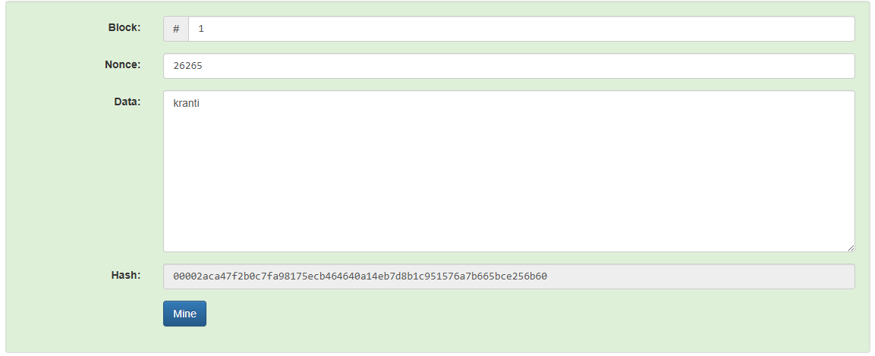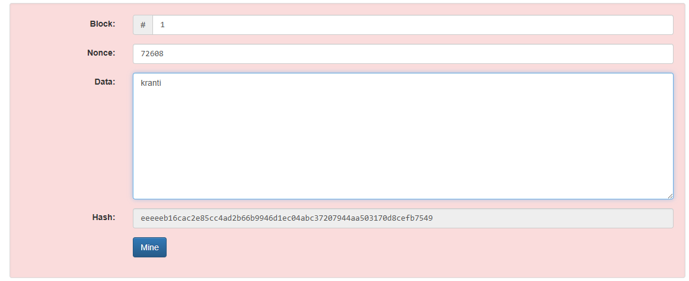

**Invalid due to data changes Valid after mining the data**

**Observation Table:**



|  |  |
| --- | --- |
| Previous hash | After adding data |
| 5ac4f1bc689f8b79e109db1d011a79c7180152d744cc8fc5125f8bbe50d97851 | 0000b456c5e285437c3bcf8a7785ae4ebdf35373e9d8c440f338410d2b76140f |

